EAST HUSKER CONFERENCE SOFTBALL TOURNAMENT @ Dodge
SATURDAY, SEPTEMBER 23rd

Pool A
#1- Twin River
#4- Highway 91
#5- Tekamah-Herman
South Field |  | North Field
Twin River vs. Highway 91 | Round 1 | NEN vs. NBC
Highway 91 vs. Tekamah-Herman | Round 2 | NBC vs. Cuming County
Twin River vs. Tekamah-Herman | Round 3 | NEN vs. Cuming County
3rd Place Game | Round 4 | 5th Place Game
Championship game | Round 5

Pool B
#2- NEN
#3- North Bend Central
#6- Cuming County
Schedule:
Round 1- 9:00am
Round 2- ~10:45am
Round 3- ~12:30pm
Round 4 (3rd and 5th place games)- ~2:15pm
Round 5 (Championship)- ~4:30pm

The higher seed is home and will occupy the 3rd base dugout.
For 5th, 3rd, and championship games, a coin flip will determine home team.

All times are approximate after the 9:00 games. We will play earlier than scheduled when possible.

Format: Games will begin at 9:00 a.m. We will play continuously until the completion of the tournament. Games are seven innings. International tie breaker rule after 7 innings will be used. Games will be played under the 90-minute time limit. The 12-run rule after 3 innings, 10 after 4 innings, and 8 after 5 innings will apply.

Pre-Game: Each team will have 10 minutes of infield prior to the first game. Remaining games will not have scheduled warm-up time. We will have a 15-minute break between games to drag and re-chalk. Teams may use the outfield during this time.

Umpires: Lane Gottula, Megan Herz, Ron Jones, Greg Lovette, Rodney Martin, Paul Teaford

Location: Holsten City Park, Dodge, NE

Admission: $5—Adults, $5—Students. EHC Administrator Passes accepted

Rosters: Rosters will be taken from the EHC Roster page

Awards: 1st and 2nd place teams will receive EHC Plaque Inserts.

Jordan Brabec, AD
Howells-Dodge Consolidated Schools
jbrabec@hdcjags.org
cell: 402-649-1576

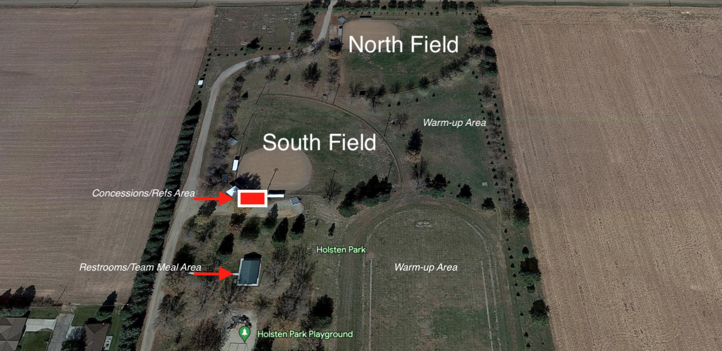
- Holsten Park Map

