|  |  |  |  |  |  |
| --- | --- | --- | --- | --- | --- |
|  |  |  |  |  |  |
|  |  |  |  |  |  |
|  |  |  |  |  |  |
|  |  |  |  |  |  |

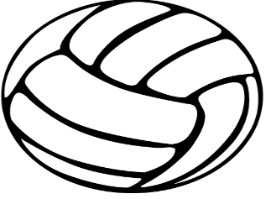

[This Photo](http://frenchmusicandpoetry.wikispaces.com/Calligrammes) by Unknown Author is licensed under [CC BY-SA](https://creativecommons.org/licenses/by-sa/3.0/)

**2022 Team Play Camp Schedule**

**Saturday, July 16, 2022**

Hosted by Dickson Middle School

401 E. College Street, Dickson, TN 37055

No Team Fee

**Admission for Spectators—$5** Elementary and younger free.

**Please, no outside food or drink allowed in the building**.

A concession stand will be available with a variety of foods and drinks. Please eat with us!

|  |  |  |  |
| --- | --- | --- | --- |
| # | Morning wave | # | Afternoon wave |
| 1 | William James | 6 | William James |
| 2 | Dickson 2 | 7 | Dickson 2 |
| 3 | Waverly 1 | 8 | Waverly 2 |
| 4 | Sycamore | 9 | Summertown |
| 5 | Dickson 1 | 10 | Dickson 1 |

|  |  |  |
| --- | --- | --- |
| Morning wave TIME | COURT 1 | COURT 2 |
| 9AM | 1 VS 2 | 4 VS 3 |
| 10AM | 4 VS 5 | 1 VS 3 |
| 11AM | 5 VS 2 | 1 VS 4 |
| 12PM | 2 VS 3 | 5 VS 1 |
| 1PM | 2 VS 4 | 3 VS 5 |

|  |  |  |
| --- | --- | --- |
| Afternoon wave TIME | COURT 1 | COURT 2 |
| 2PM | 6 VS 7 | 8 VS 9 |
| 3PM | 9 VS 10 | 6 VS 8 |
| 4PM | 10 VS 7 | 9 VS 6 |
| 5PM | 7 VS 8 | 10 VS 6 |
| 6PM | 7 VS 9 | 8 VS 10 |