H. PHASE #8 ….. Extension #2

1. Top hand stays under the bat.

2. Continuation of 1'st extension.

3. Back shoulder rotates forward.

4. Weight will flow slightly back.

5. Lead arm begins to form a V.

6. Back arm extends across the body and begins to form an L.

7. The head stays down.

8. The lead eye stays inside the stride leg thigh.

9. The belly button takes a picture of the pitch.

10. The wrist have not yet began to roll.

11. Short bat path to finish.

12. Good Backside L.
Page # 27

Extension #2 …. Cont.
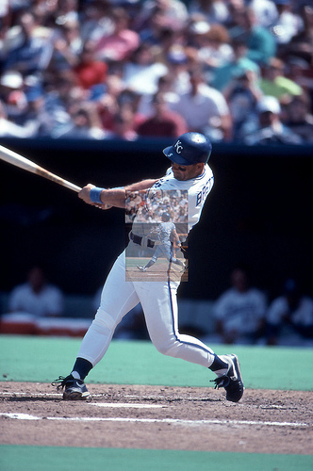
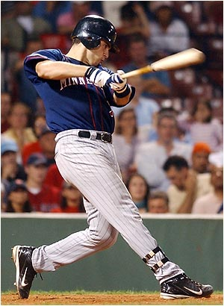

Page # 28

Extension #2 …. Cont.

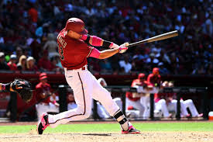

Page # 29

