C. PHASE #3 ….. Stride and Cock the Bat

1. Stride is locked in to the length of the bat.

2. Stride to the inside ball of the front foot with front heel just off
the ground.

a. You must get “ Stronger to the Ball “ and flexed front leg.

1.) All 6 joints in the front side stay together and take
you to the ball.

a.) Ankle Joint b.) Knee Joint
c.) Hip Joint d.) Shoulder Joint
e.) Elbow Joint f.) Wrist Joint

3. Front side knee, hip, and torso and will remain flexed.

4. Gain Momentum into the approach. Head moves to a mid-point.

5. BACK KNEE REMAINS ANCHORED!

6. Established a "POWER BASE" for the hit phases of our swing.

7. Hands finish load and remain back and maintain shoulder
alignment throughout the stride.

8. Lever Assembly Maintain the Box and Bat Angle and Moves into
a Position of Power with or without the 10 degree rule.

Page # 11
C. PHASE #3 ….. Stride and Cock the Bat
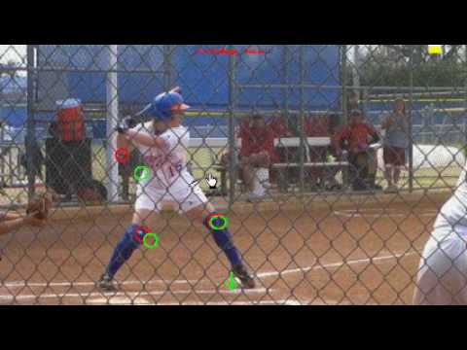

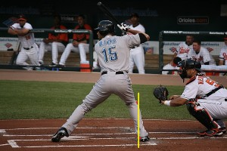

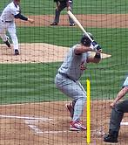

Page # 12
PHASE #3 ….. Stride and Cock the Bat
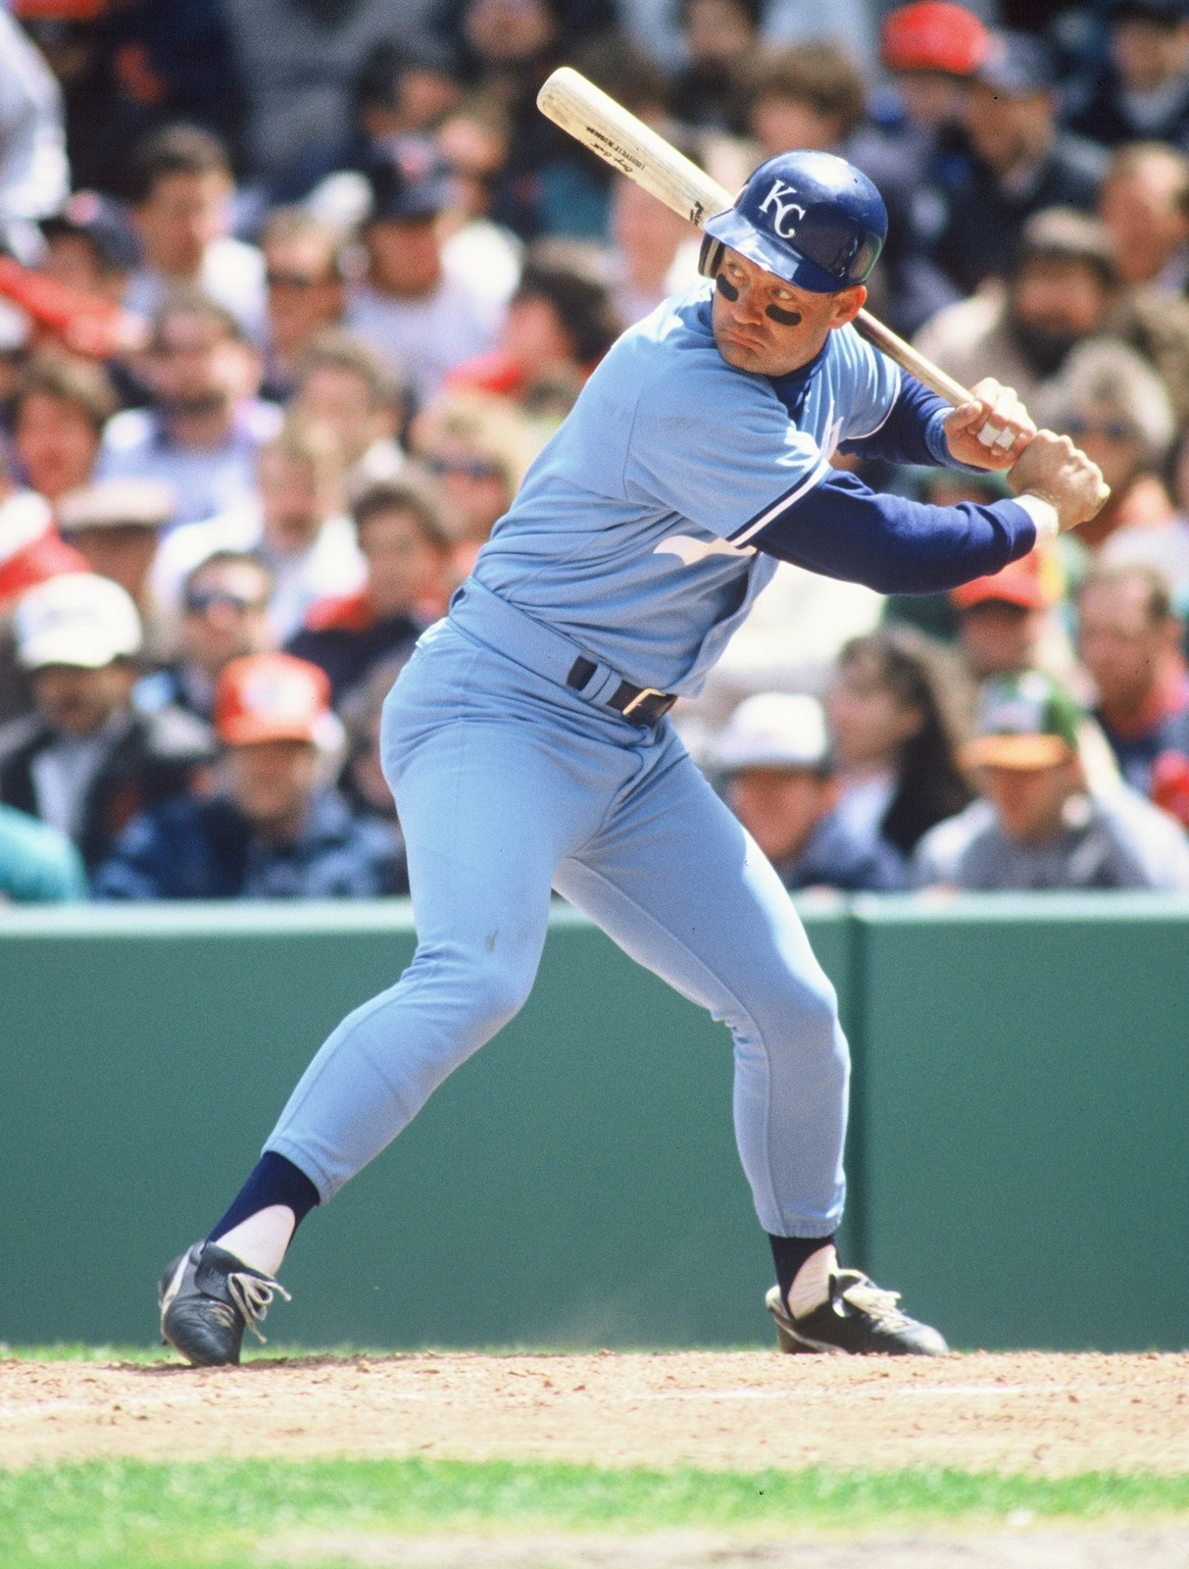
Page # 13
PHASE #3 ….. Stride and Cock the Bat

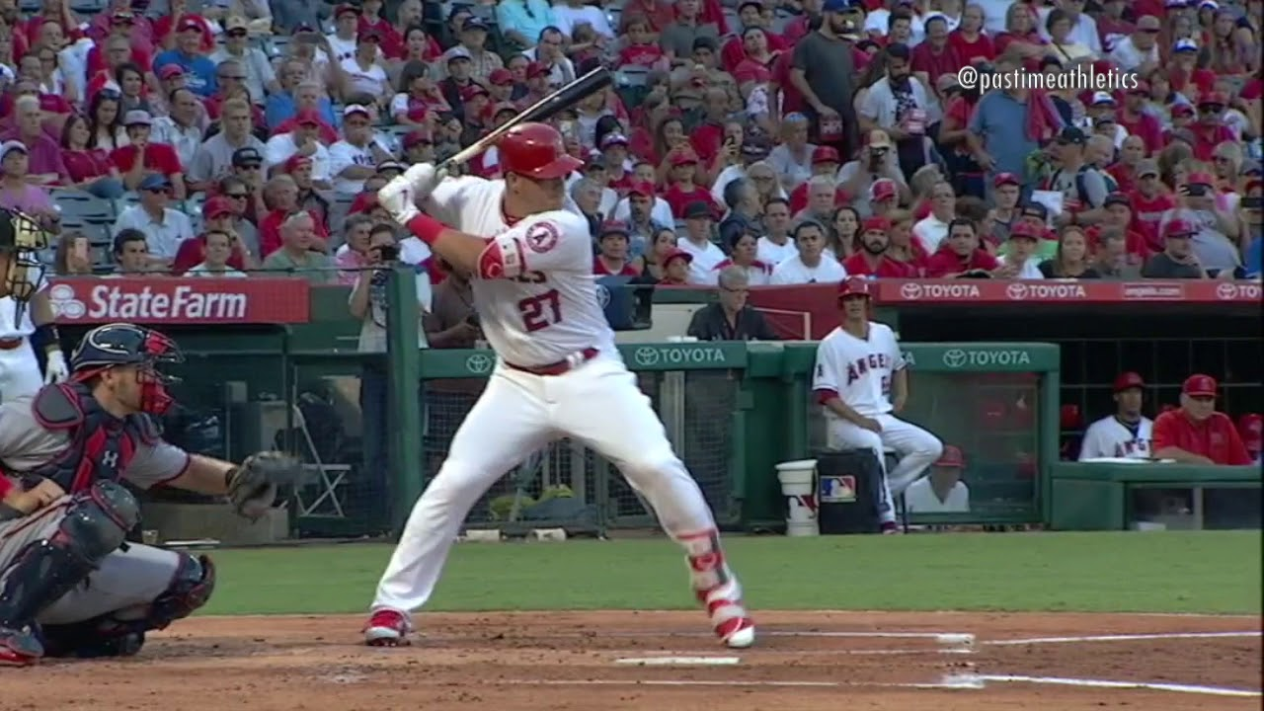

Page # 14

