CLARKSTOWN HOCKEY NEWS

The Clarkstown Hockey Team quietly disposed of the Sleepy Hollow Legends 8-0 Wednesday night at the Palisades Mall Rink in front of a small but energetic loud crowd.

The first period ended in a 0-0 tie as Adam Pesce goalie for Sleepy Hollow and brother of University of New Hampshire defensemen Brett Pesce and future defensemen for the Carolina Hurricanes stood on his head to keep Clarkstown off the Board.

Nick Sassano led all scorers with a hat trick and 2 assists, he was in a zone. Timmy Cavanagh pitched a shutout for his 3rd of the year. It should be noted that this was the first game this season that Clarkstown did not incur any penalties therefore making for a quick game. Sleepy Hollow did try to entice a few of Clarkstown players into a fight towards the end of the 3rd period but Clarkstown would have none of it. I did ask one Clarkstown player who will remain nameless what he said to the Sleepy Hollow captain who knocked him down in anticipation of retaliation, his reply; “Hey pal look at the scoreboard” then he proceeded to walk away.

Coach Willows and staff did change things up throughout the game to see what works, different wrinkles here and there. One thing was consistent Clarkstown keeps coming and coming at you. There were many times where it seemed that Clarkstown was always on a Power Play.
Clarkstowns next opponent will be Monroe Woodbury on Wednesday January 29th, 6:05pm, at the Palisades Mall.

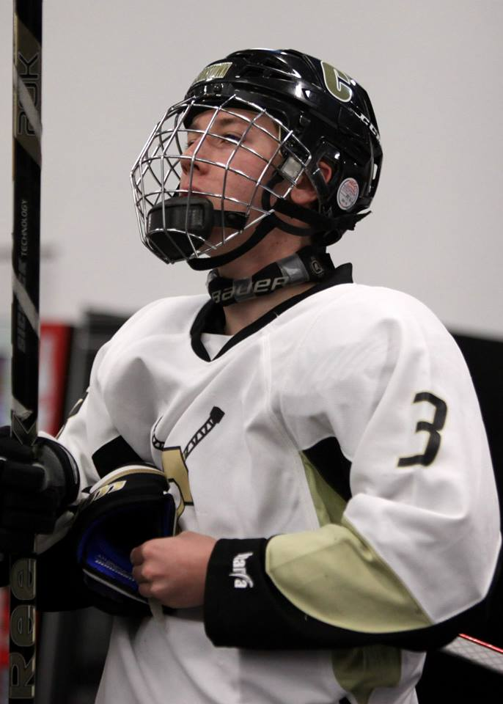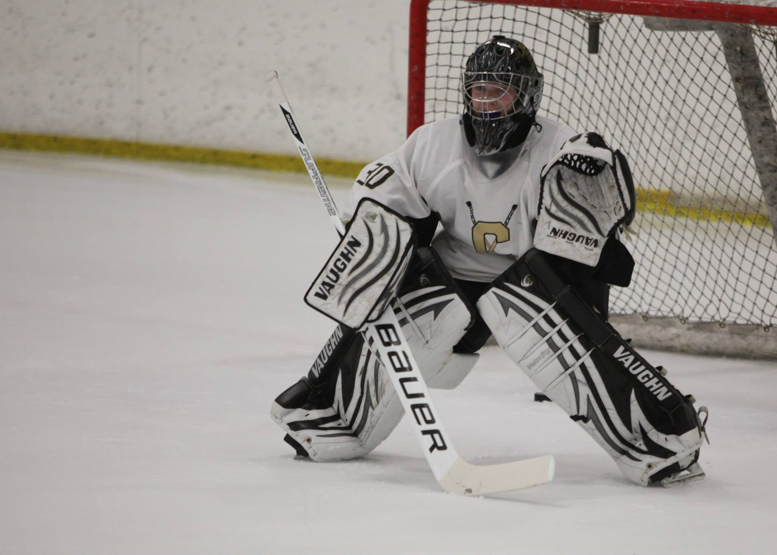
NICK SASSANO #3 TIMMY CAVANAGH #30

01/23/14

