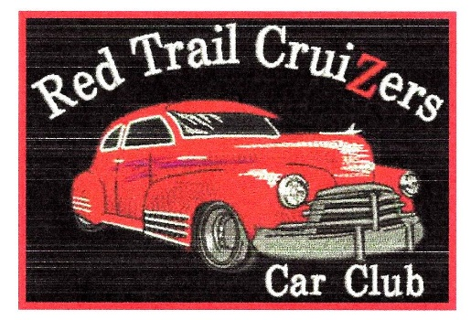
Red Trail CruiZers Car Club Meeting
Annual General Meeting
Thursday, April 13th, 2023
Second Chance Museum
Treherne, Manitoba

In attendance where Brian Bambenek, Bud Frizzley, Barb Grift, Harvey Grift, Gerald Grift, Wayne Preston, Ray Grift, Scott Smart, Garry Jansen, Eric Cabernel, Kyle Turner, Ken Van Deynze, Linda Van Deynze, Tamara Greenly, Stuart Hooey, Patti Hacault and Shawn Zeghers.

- The AGM meeting was called together at 7:00 p.m. by President Shawn Zeghers. Tamara Greenly was the recording secretary. Sixteen members were in attendance.
- Adoption of the Agenda
Motion: Barb / Stuart – Carried
Moved the adoption of the agenda.
- Secretary’s Reports
Motion: Tamara / Wayne – Carried
That the 2022 AGM Meeting minutes, as circulated, be approved.
- Treasurers Report
Motion: Wayne / Tamara – Carried
The current balance is $2,000.00. Club dues ($25) are coming in.
Motion: Barb / Garry – Carried
That the website fee ($21) be paid.
- MAAC Report
Wayne picked up the car show programs in Winnipeg - members received some and the rest were left at the museum. MAAC meetings have been conducted on zoom. Problems with finding an insurance carrier to meet their meets. Each member club pays $273.
- New Business
Car Show - will return on July 1st date and will be held at the Holland Fairgrounds.
Action # 1
Motion: Barb / Harvey – Carried
“That four chairs are to be purchased as prizes (Approx $70.).”
Action # 2
The Three Bert’s’ band has been booked.
Action # 3
Car club will have to pay a rental fee for the facilities. However, they may be able to share a grant that Craig Soldier has obtained.
Action # 4
The Car Club will run draws and 50/50 similar to last year. Credit Union will supply the draw tickets.
- Elections: Call for members to fill executive positions. Barb will continue with membership, Gerald will do the posters, banners, and membership cards. Shawn will continue as President. Patti to continue to maintain the website.
- Upcoming Events:
Janice Wiebe from Austin is holding a quilt show at her farm on May 28th and would like cars to attend.
9. Museum Update: Ken and Linda Van Deynze updated the museum activities and progress. Members notice many additions in the museum such as a Drive In Movie Screen and a sound system. They will be working to complete the East entrance building side.
- Next Meeting will be on May 16th at 7:00 p.m. at the Car Museum Gerald
- The meeting was adjourned the meeting at 8:00 p.m. by Barb.

